

VSTS Code Review

Guidelines Steps for Code Review



|  |  |  |  |
| --- | --- | --- | --- |
| **Document Revision History** | | | |
| **Version No.** | **Author** | **Revision Comments** | **Date** |
| 1.0 | Navpreet | Draft Version | 09-11-2017 |
|  |  |  |  |
|  |  |  |  |
|  |  |  |  |
|  |  |  |  |

#### **Introduction: -**

#### We have to use Peer to Peer review options available in Visual studio and follows the Microsoft guidelines. You can use Visual Studio to ask your colleague from your team to review it. Your request will show up in his team explorer, in my work page. You can use this feature in all VS versions: - VSTS | TFS 2018 | TFS 2017 | TFS 2015 | VS 2017 | VS 2015 | VS 2013.

#### **How to Request for a code review**

1. Before Developer checks in the change, Requester goes to my work page.

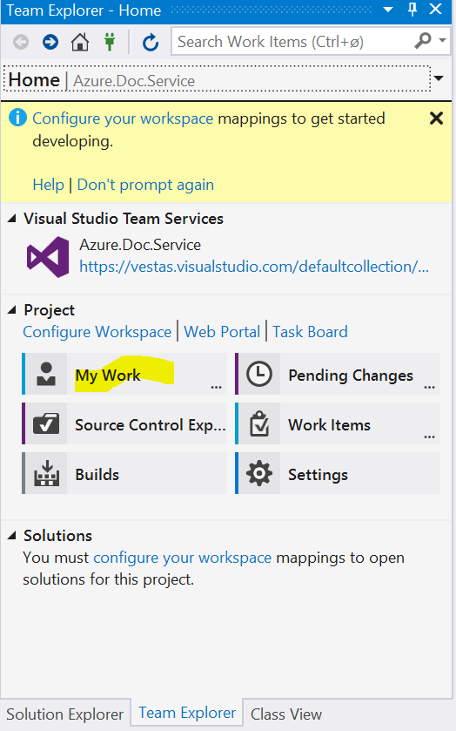

1. Developer Request a Review.

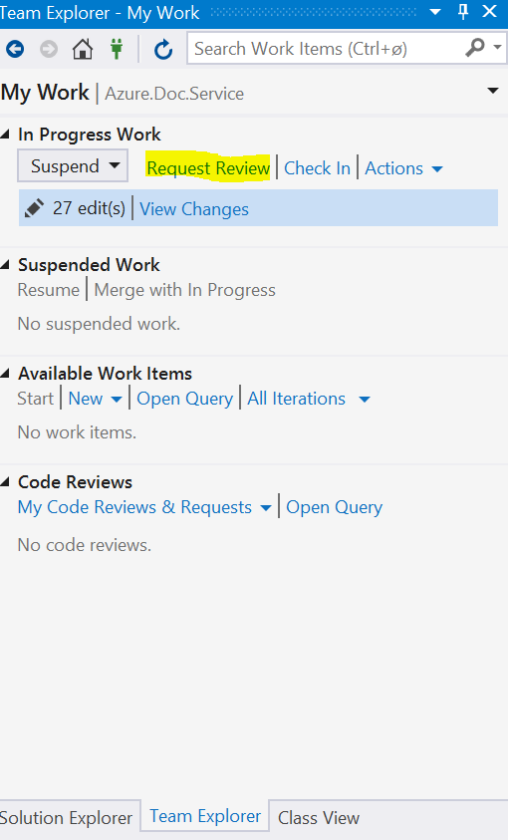

3. Developers submits a request to Reviewer (Colleague) with following details added in request.

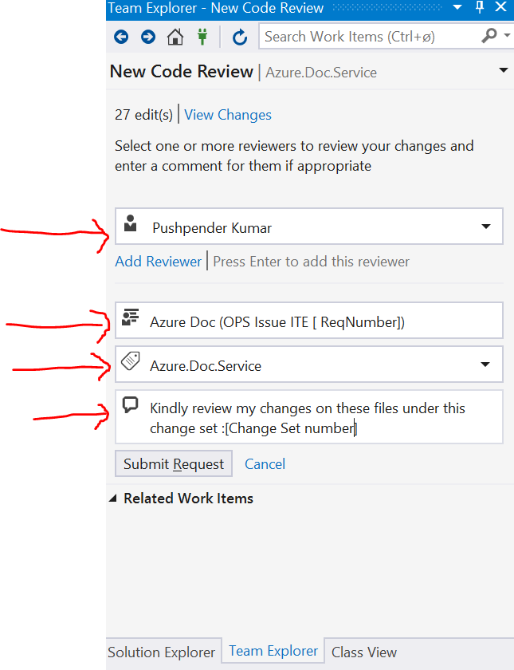

4. Developers suspends his work on his code so that he can work on something else while he waits to hear back from Reviewer.

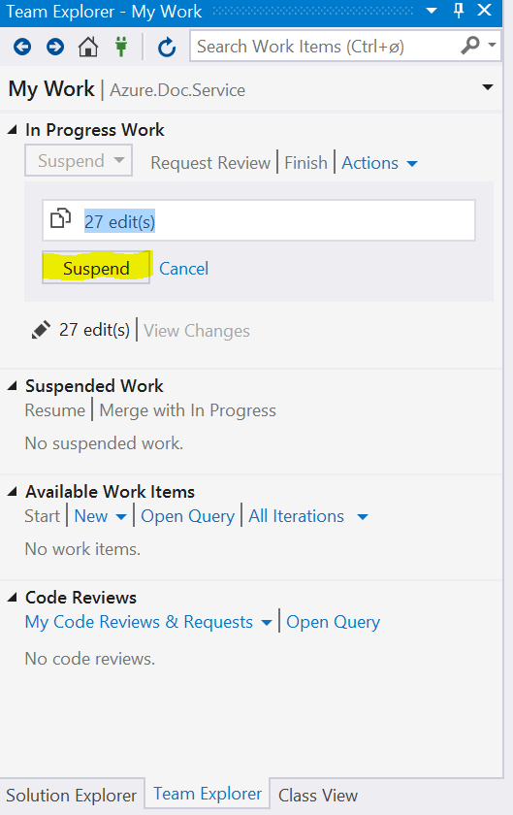

#### **How to Respond to the code review request**

1. Reviewer will see the code review request in the team explorer, look at the changes, and give Developer his feedback.

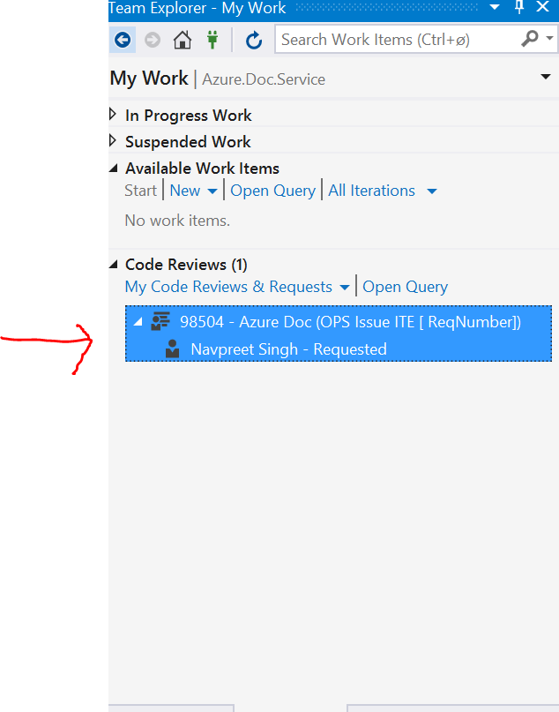

1. Reviewer sees Developers’ code review request. 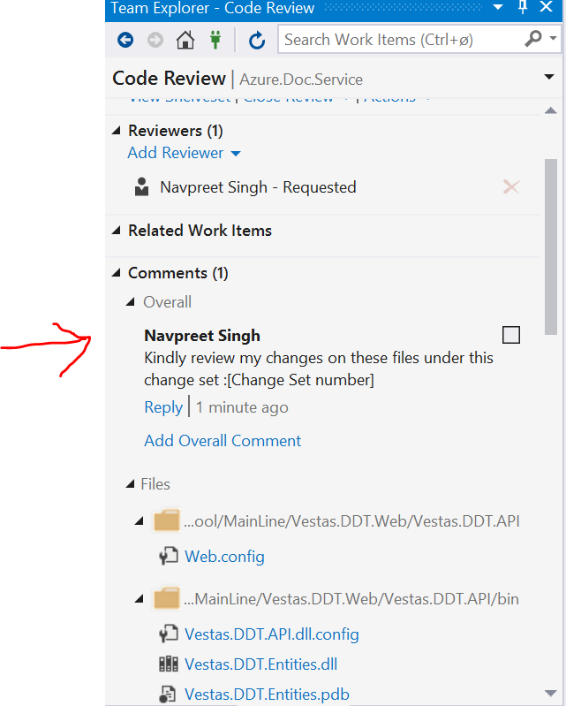

3. Reviewer suggests an options by comparing the code and can change or add comments on lines and files.

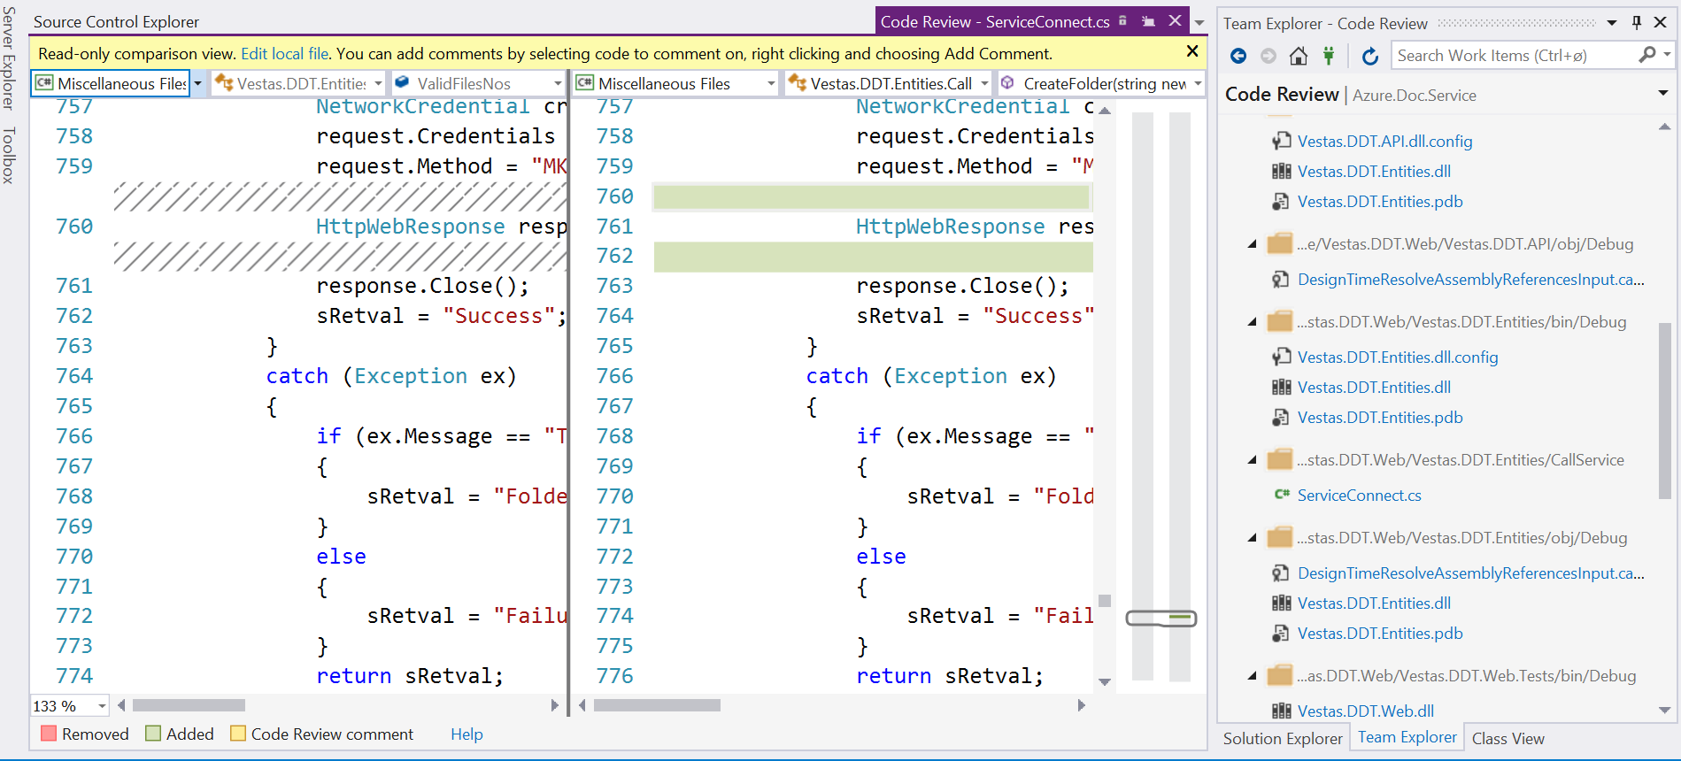

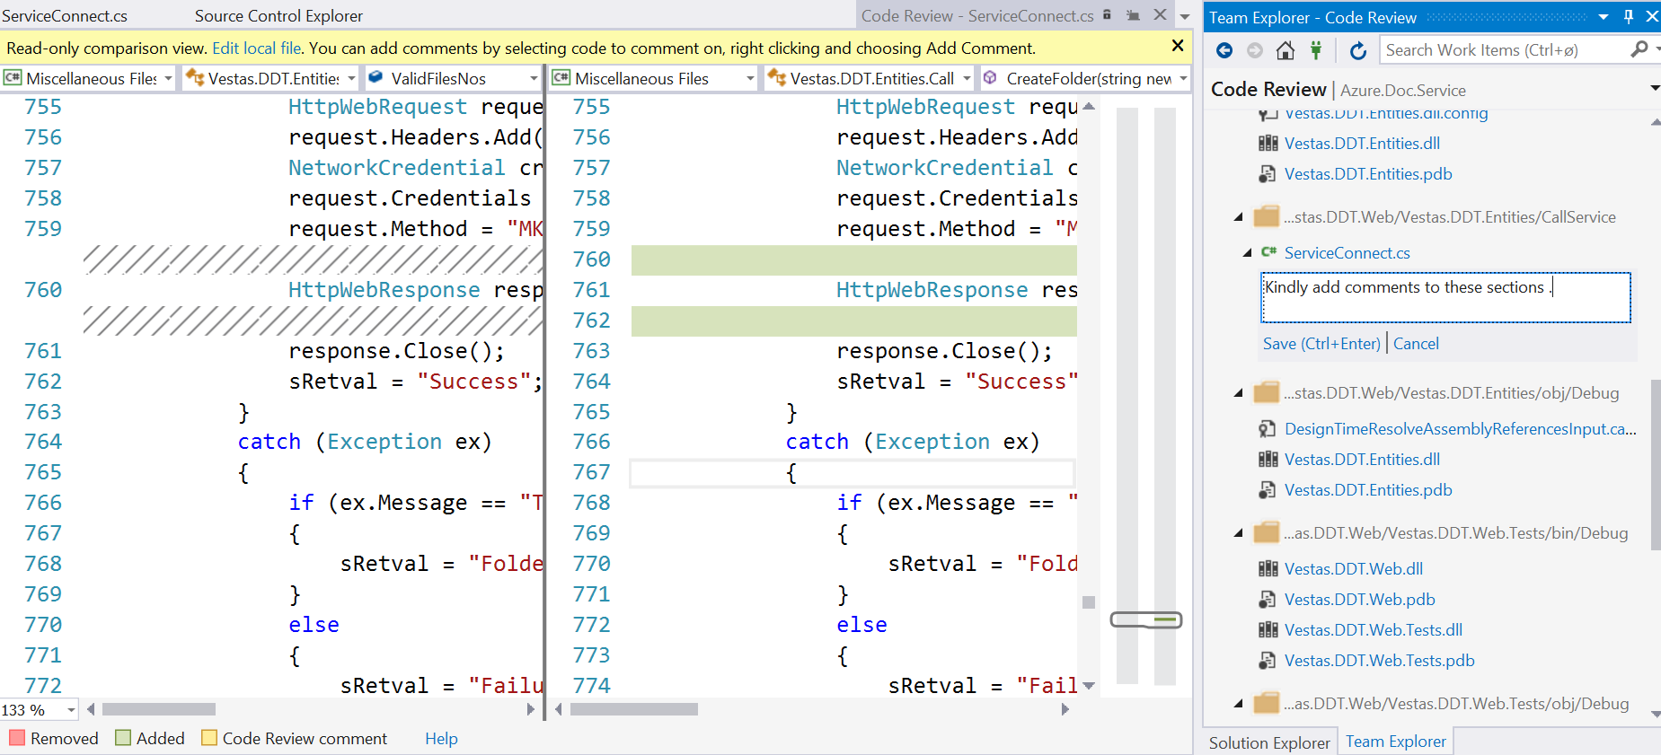

4. After reviewing all files , reviewer will add overall comments on the files and send the feedback back to devlopers .

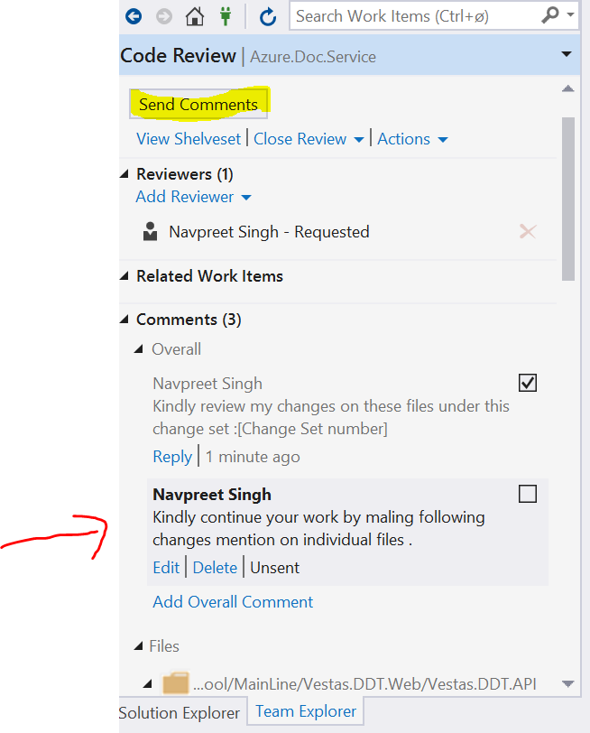

#### **Update the code based on the review feedback**

1. Developer will accept the review comments and resume his work on that changes .

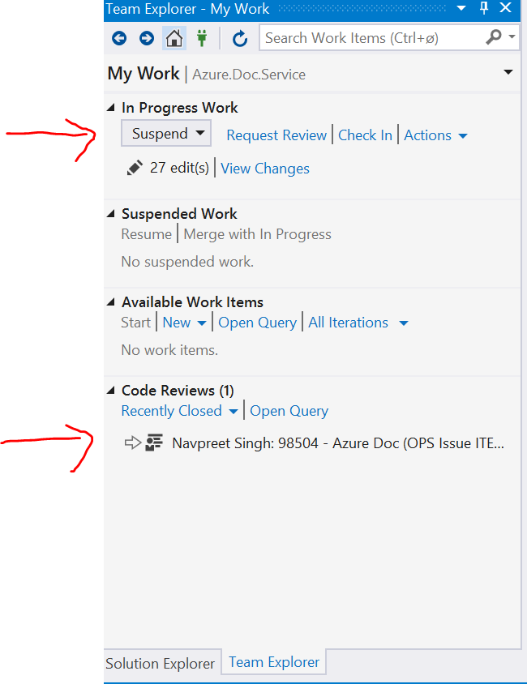

Kindly use following link for more details .

<https://docs.microsoft.com/en-us/vsts/tfvc/get-code-reviewed-vs>

We need to use Microsoft and Vestas guidelines for code review .